**Experiment 3**

**Aim:** To execute Linux networking commands.

**Software:** Ubuntu

**Commands:**

1. ifconfig

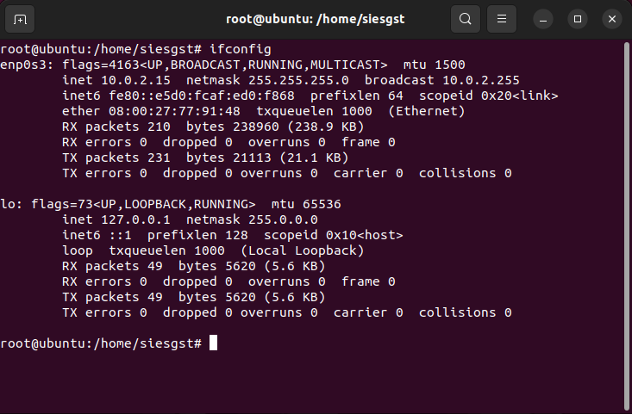

1. ifconfig –a

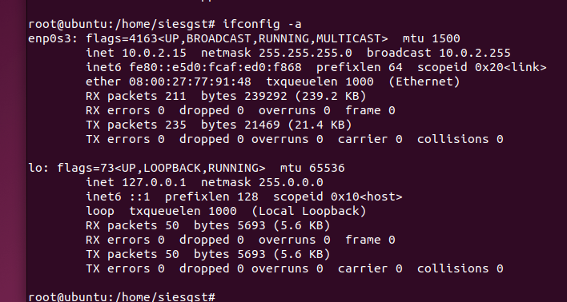

1. ifconfig ip address

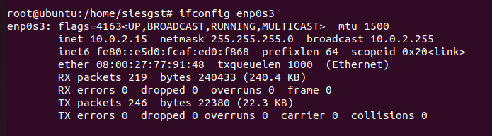

1. ifconfig lo

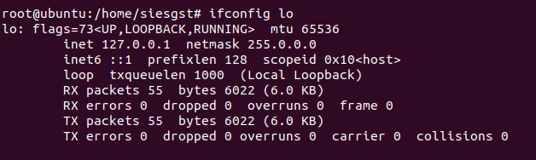

1. ifconfig ipadress up/down

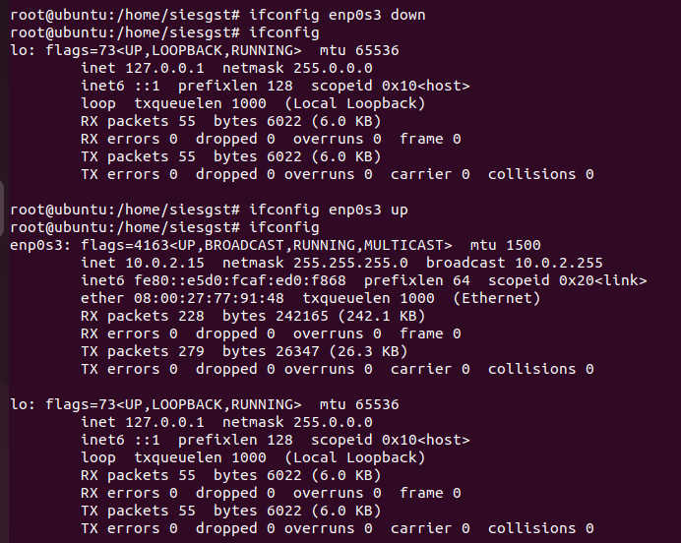

1. ifconfig ipaddress

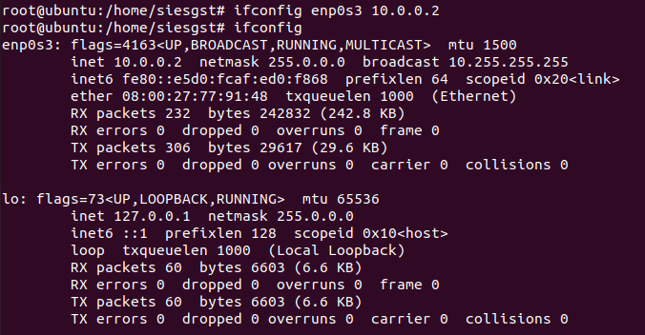

1. ifconfig ipaddress mtu

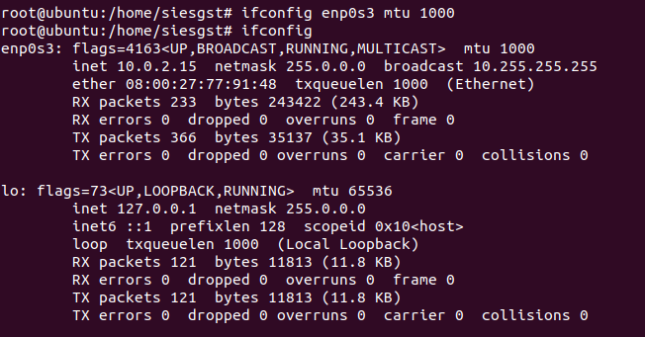

1. ping ipaddress/google/i 6/i 0.9/-c 5/

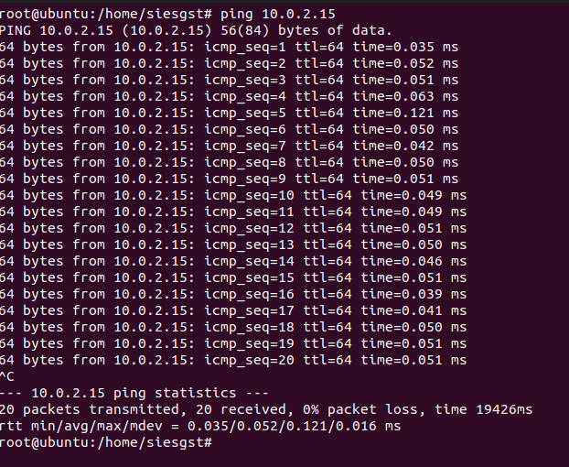

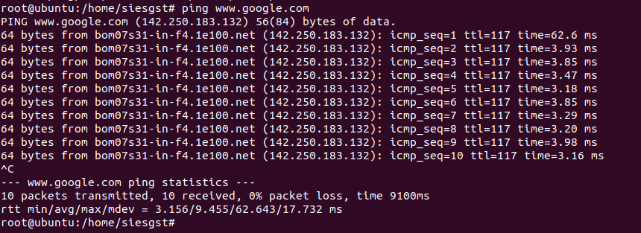

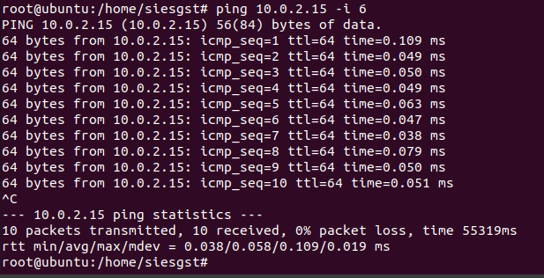

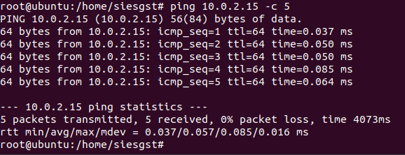

1. netstat / -t/ -u/ -a/ -x

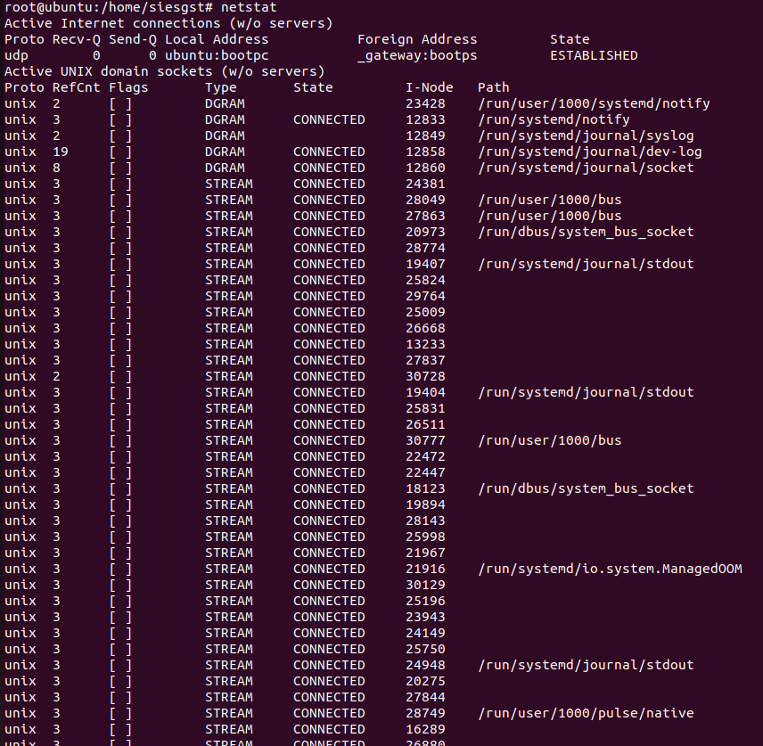



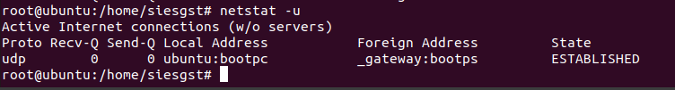

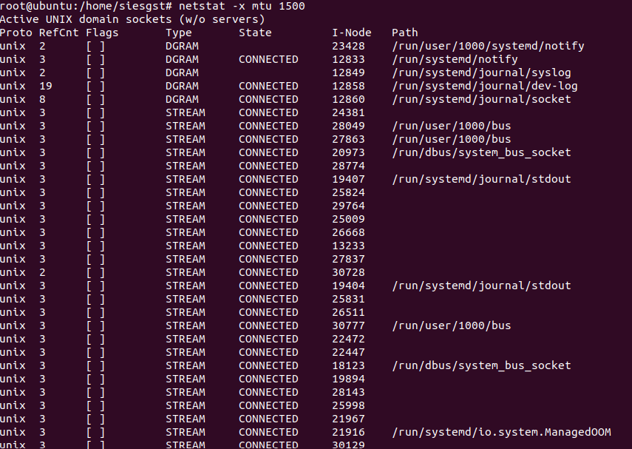

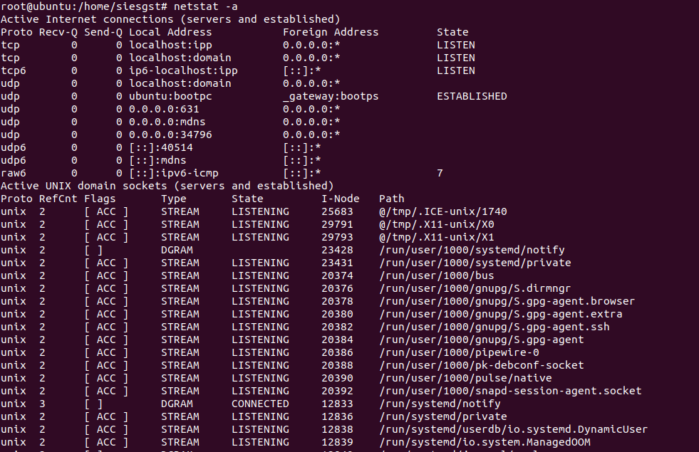

1. traceroute [www.google.com](http://www.google.com)

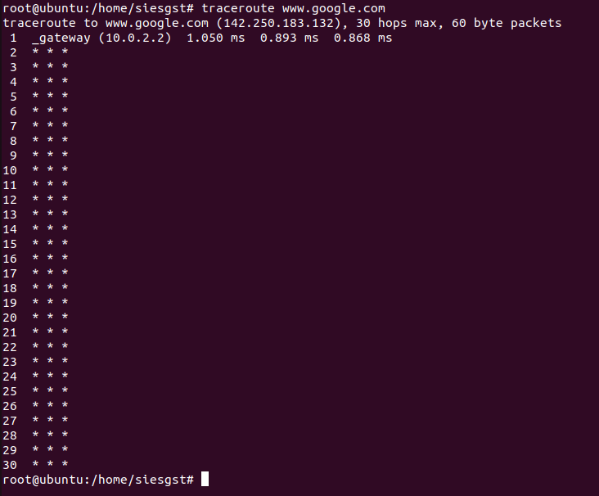

**Conclusion:**

Basic networking commands of Linux were understood and executed successfully.